**Backend Concepts of Recommendation Systems**

**Cosine Similarity**

**Euclidean Distance**

**Pearson**

**Time Similarity**

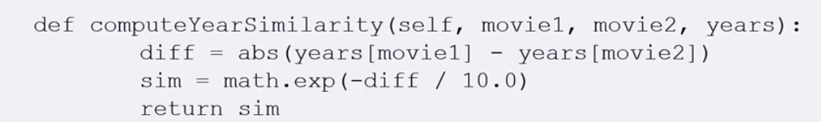

**K-Nearest Neighbors**

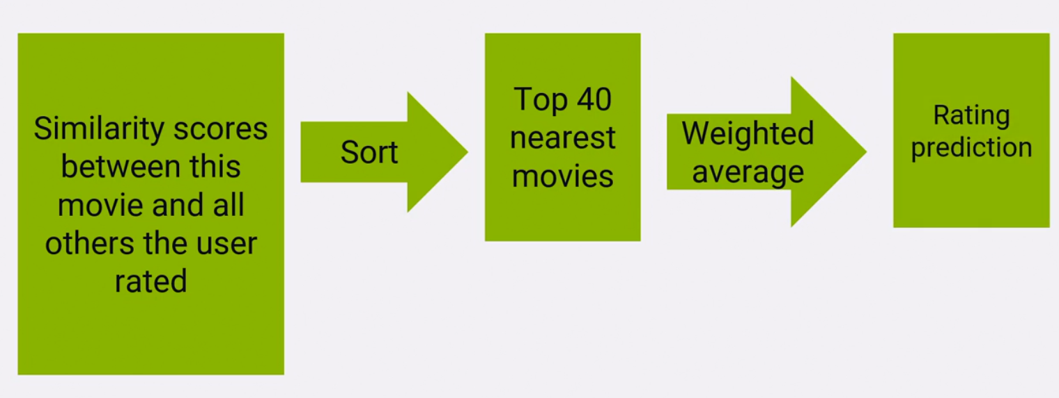

**Mise en scene similarity**

**Adjusted cosine similarity**

* So all that's different here from conventional cosine similarity is that we're looking at the variance from the mean of each user's ratings and not just the raw rating itself.
* Data sparsity could really screw this up though. We need an abundance of ratings to begin with for us to take the average of the user ratings.

**(Item-based) Pearson Similarity**

**Spearman Rank Correlation**

* Main advantage can be used for ordinal data. Not very commonly used

**Mean Squared Difference**

**Jaccard Similarity**